
MATHEMATICS DEPARTMENT
Year 11 Specialist – 2016
Test Number 6: Resource Free
Trigonometric Identities and Complex Numbers

Name: _______________________________________ Teacher: DDA
Marks: 52
Time Allowed: 45 minutes
Weight: 7%
Instructions: Show your working where appropriate remembering you must show working for questions worth more than 2 marks. ________________________________________________________________________
Part A 9 multiple-choice questions
1 sec (45°) =
A
B
C
D
E

[1 mark]
2 cos =
A −2
B
C
D
E [1 mark]
3 sec =
A −sec
B −cos
C cos
D sec
E sec

[1 mark]
4 cos (270° − α) =
A sin (α)
B −sin (α)
C cos (α)
D −cos (α)
E cos (270°)

[1 mark]
5 The graph shown below could have the equation:
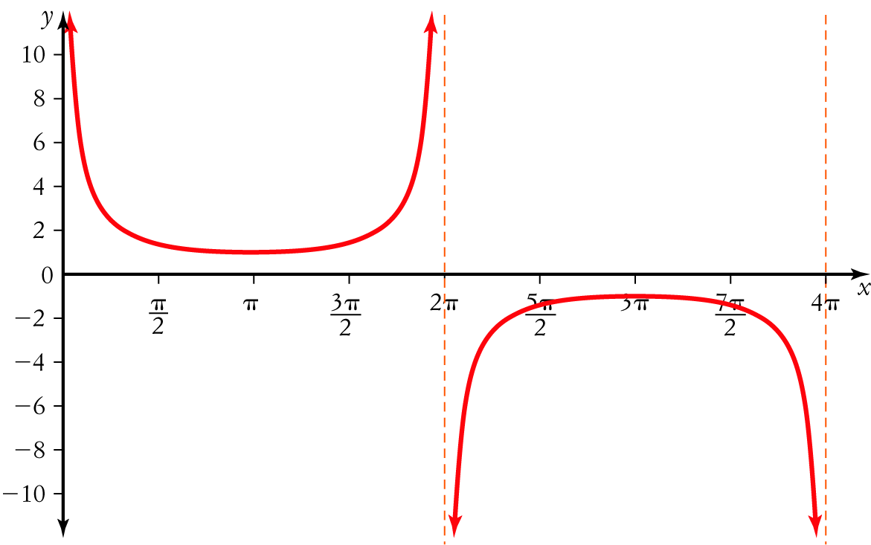
A y = 2 cosec (x)  B y = 2 sec (x − 1)  C y = cosec (x) | D y = sin (x)  E y = cosec
[1 mark]
6 The value of is:
A 9 − 16i
B 25
C 5
D 9 + 16i
E −7

[1 mark]
7 The roots of x2 − 4x + 5 = 0 are:
A x = 2 ± i
B (x − 2 − i)(x − 2 + i)
C x = −2 ± i
D x = −4 ± i
E x = 4 ± i

[1 mark]
8 If then the value of v2 is
A 2
B i
C 2i
D 4i
E 4

[1 mark]
9 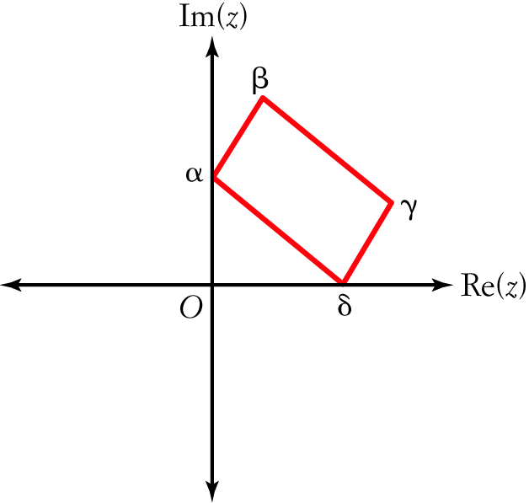
In the diagram, the complex numbers α, β, γ, δ form a parallelogram, such that α and δ lie on the axes. The point β is described by:
A α + δ + γ
B α + δ − γ
C α − δ − γ
D α − δ + γ
E −α − δ − γ

[1 mark]
Part B
9 short answer questions
35 marks
Show your working where appropriate.
10 Sketch the graph of y = −cosec (x) − 1 for 0 ≤ x ≤ 4π.
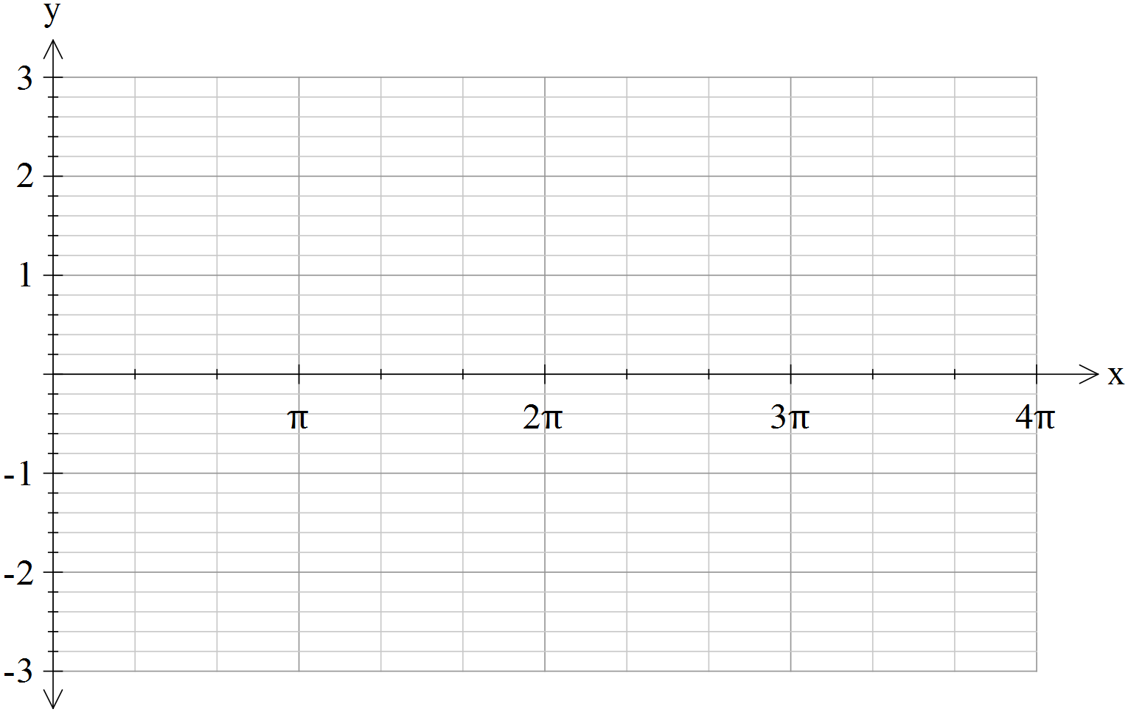

[4 marks]

Working and thinking space. Anything on this page below this line will not be marked.


11 Using the identity 1 + tan2 (θ) = sec2 (θ) evaluate given that .
[ Your answer should be simplified to the form $a+b\sqrt{c}$ ]

[3 marks]
12 Using a suitable compound angle formula evaluate cos.

[4 marks]
13 Express sin sin as a sum.

[3 marks]

14 a Solve z2 + 3z + 3 = 0 over the complex plane.

b Sketch the solutions to z2 + 3z + 3 = 0 on an Argand diagram, labelling them z1 and z2.
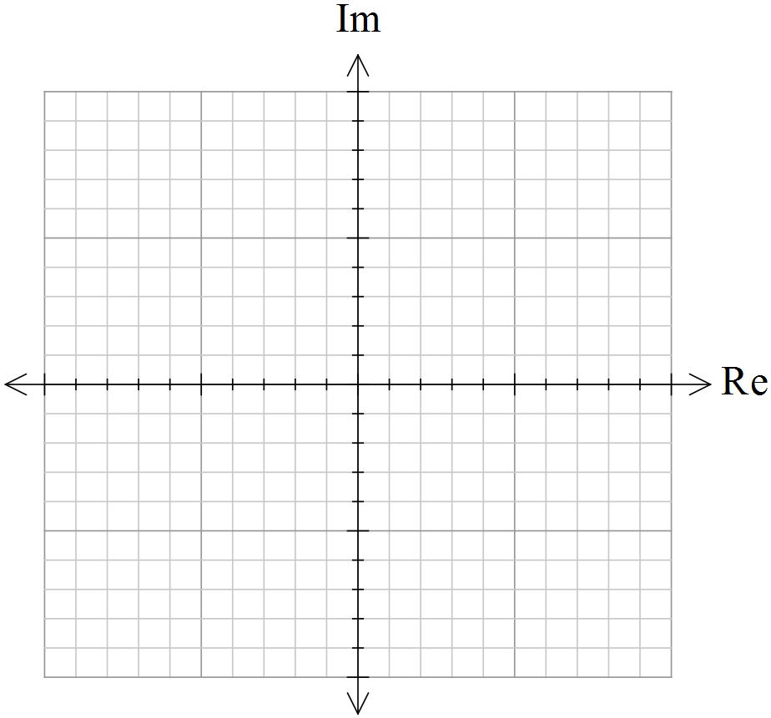

c What geometric property do the complex roots of quadratic equations with real coefficients display?

[3,2,1 = 6 marks]
15 If (a + bi)2 = 5 + 12i, where a, b ∈ R. Find all possible values of a and b.

[5 marks]

16 If z = 6 + 8i find in simplest form:
a z⁻1

b

c .

[6 marks]

17 If w = x + yi, where x, y ∈ R, show that:
a

b

[4 marks]

Part C
2 analysis questions
8 marks
Show your working where appropriate.
18 Rewrite the expression sin (2x) cosec (x) − sec (x) cos (2x) in terms of cos (x) only.

[3 marks]

19 Prove that cot2 (2θ) = .

[5 marks]

